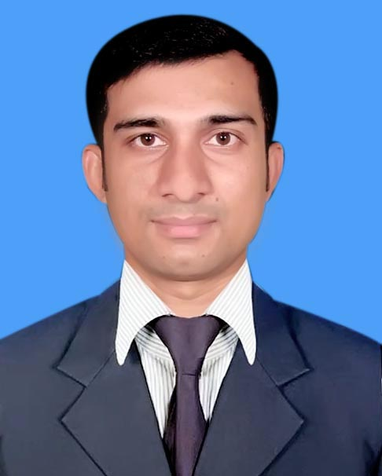
RESUME

Shuzon
BA (Hon’s), Political science
Cell: +8801733124335
Email: shuzon1991@gmail.com

Career Objective :
A young energetic self motivated person with a view to build up career with a renowned organization like yours to learn and work in a challenging and competitive environment with the professional team and seek a significant position in the area of Chemist with ample prospect to develop my career which results in a long term career growth.

Educational Qualification :

Period | Details
2012 | BA (Hon’s) In Political science  National University, 2nd class
2008 | H.S.C in Humanaties group  3.70 GPA, Dhaka Board,
2006 | S.S.C in Humanaties group  4.50. GPA Madrasha Board,

Language Skill :

Languages | Reading | Writing | Speaking
1. Bengali | Excellent | Excellent | Excellent
2. English | Excellent | Excellent | Smart

Key Skills :

* Capable of working both independently and co-operatively in a team
* Generate ideas and develop new books and perform editing function
* Excellent organizational and communication skills
* Having a good hand at computer
* Capable of maintaining a good relation with the clients and staff members
* Effective conflict resolution and team leadership skills
* Very good temperament and enjoy challenges

Specialization :
Computer Skill:  Other Activities: | ● Able to work with Office Programs.  ● Graphics Design & Multimedia Course.  ● Well Known about internet browsing.  ● Attended and Arranged co curricular activities like Debating, Extempore Speech, Essay Writing etc. during my educational life.
Personal Details :

Name : |  | Shuzon
Father's Name : |  | Mojibar Rahman
Mother's Name : |  | Sufia
Date of Birth : |  | January 05, 1991
Gender : |  | Male
Marital Status : |  | Unmarried
Nationality : |  | Bangladeshi
Religion : |  | Islam
Present Address : |  | Vill:Muchidah,Post:Puijor,Upozila: Pangsha,Dist: Rajbari
Permanent Address: |  | Vill:Muchidah,Post:Puijor,Upozila: Pangsha,Dist: Rajbari
Current Location |  | Dhaka
Mobile : |  | +8801733124335
Email : |  | shuzon1991@gmail.com

Reference(s): | No. 01 | No. 02
Name : | Mustafizur Rahman | Md. Faruk hossein
Organization : | Agrani SME Finacial Company Ltd | Agrani SME Finacial Company Ltd
Details : | Manager | 2nd officer
Phone: | +8801712873541 | +8801725025214
Relation : | Brother | Brother

Declaration of Authenticity :

I do hereby declare that all information provided above are true to my knowledge and this document can be supported by appreciate authentic certificates and papers if required.

Shuzon

Signature

